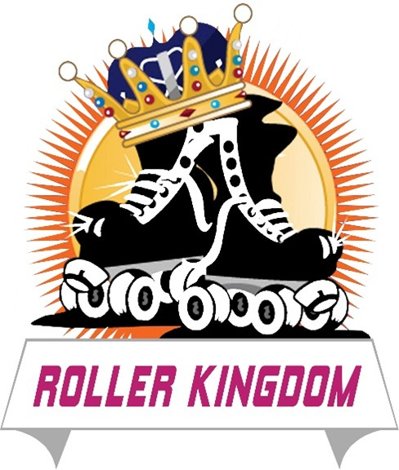

ROLLER KINGDOM LLC
Outdoor Event Rental Agreement
Phone: 240-405-6828
Email: rmcintosh@rollerkingdom.net
Service Area: Waldorf, Maryland & surrounding DMV area
This Agreement is entered into between Roller Kingdom LLC (“Provider”) and the Client listed below for the rental and temporary use of Roller Kingdom’s mobile roller rink and associated equipment.
1. EVENT DETAILS
Event Name: ______________________________________________
Event Location: ______________________________________________
Event Date(s): ______________________________________________
Event Hours: ______________________________________________
Expected Attendance: ______________________________________________
2. RENTAL PACKAGE INCLUDES
- 50 ft x 30 ft professional outdoor roller rink with Junckers hardwood sports flooring.
- Sports Prowall perimeter barrier system.
- Inflatable Roller Kingdom archway entrance.
- Professional-grade sound system.
- Setup and breakdown by Roller Kingdom staff.
- Roller skate rentals for participants.
- Safety lighting and event signage.
- Optional Add-Ons:
- DJ or live music technician
- Decorative branding enhancements
- Additional skate rentals
- Extended hours or multi-day events
3. FEES & PAYMENT TERMS
Rental Fee: ______________________________________________
Deposit (non-refundable): ______________________________________________
Remaining Balance: ______________________________________________
Accepted payment methods: Credit Card, Check, Cash App, Zelle, or Electronic Transfer.
Late payment penalties: 5% per week overdue.
4. CANCELLATION POLICY
- Cancellations 14 days or more before the event: Deposit retained, no further charges.
- Cancellations fewer than 14 days before the event: 50% of total rental due.
- Weather-related postponements may be rescheduled without penalty with at least 24 hours’ notice.
5. SITE REQUIREMENTS
- A clean, level outdoor surface of at least 60 ft x 40 ft.
- Electrical access for lighting and sound system.
- Access for delivery truck and trailer.
- Adequate overnight security if required.
6. LIABILITY & INSURANCE
- Roller Kingdom LLC carries commercial liability insurance.
- All participants must sign liability waivers before skating.
- Roller skating involves inherent risk.
7. DAMAGE & CLEANUP
Clients will be billed for any damage resulting from misuse, negligence, or vandalism. Roller Kingdom will handle basic cleanup after the event.
8. WEATHER & SAFETY
Roller Kingdom reserves the right to pause or cancel operations due to unsafe weather conditions.
9. HOLD HARMLESS
The Client agrees to indemnify and hold harmless Roller Kingdom LLC from any claims, damages, or injuries.
10. SIGNATURES
Client Signature | Date
Roller Kingdom Representative | Date

